Project Proposal

David Kelly B00060572



Fantasy Hurling Game

*with* Social Media Capabilities

19/10/2014

Contents

**1.0 Project Overview** …………………………………………………………… 3

1.1 Project Title …………………………………………………………… 3

1.2 Project Type …………………………………………………………… 3

1.3 Project Client …………………………………………………………… 3

1.4 Project Supervisor …………………………………………………………… 3

1.5 Project Manager …………………………………………………………… 3

1.6 Project Timescale …………………………………………………………… 3

**2.0 Executive Summary** …………………………………………………………… 3

**3.0 Introduction**  …………………………………………………………… 4

3.1 Background …………………………………………………………… 4

3.2 Existing Technologies …………………………………………………… 4

**4.0 Main Research Questions** …………………………………………………………. 4

4.1 Is there a potential gap in the social media market for a fantasy hurling game? 4

4.2 Could a fantasy hurling game create revenue for the GAA?........................... 4

4.3 Could a fantasy hurling game create social media interest for the GAA? ….. 4

**5.0 Benefits** …………………………………………………………... 5

5.1 User Benefits …………………………………………………………… 5

5.2 GAA Benefits …………………………………………………………… 5

**6.0 Feasibility** …………………………………………………………... 6

6.1 Does the team have an understanding of the technical requirements necessary? 6

6.2 Can the team create this project in the allocated time?................................... 6

6.3 Can measures be taken to aid the progress of this project?............................. 7

6.4 Will the project fit within the allocated budget?..............................................7

**7.0 Proposed Methodologies** …………………………………………………………... 8

**8.0 Expected Results** …………………………………………………………... 9

8.1 Successful Project …………………………………………………………... 9

8.2 Successful System…………………………………………………………... 9

8.3 Failed Project …………………………………………………………... 9

8.4 Incomplete Project…………………………………………………………... 9

**9.0 Conclusion** …………………………………………………………... 10

**10.0 References** …………………………………………………………... 11

**1.0 Project Overview**

**1.1 Project Title:**

Research Application Development Frameworks for JEE Development, and Develop JEE Prototype with Framework

**1.2 Project Type:**

Research and JEE Prototype

**1.3 Project Client:**

**1.4 Project Supervisor:**

Dr. Geraldine Gray

**1.5 Project Manager:**

David Kelly

**1.6 Project Timescale:**

17/9/2015 - 30/4/2016

**2.0 Executive Summary**

This proposal explores the potential gap in the market for a fantasy hurling game. The GAA have recently signed a three-year contract with Sky Sports and their coverage of hurling has the possibility of attracting fans worldwide. A fantasy hurling game could capitalize on this interest and give fans a chance to interact via a social media game.

Research conducted on already existing fantasy sports games not only shows improved website views but also a direct relationship with social media. Estimated data from [www.alexa.com](http://www.alexa.com) shows that ~79% of visitors to [www.premierleague.com](http://www.prmierleague.com) visit their fantasy football sub domain. Further investigations reveal that ~13% of visitors upstream directly from social media websites Facebook and Twitter.

The official GAA Facebook page has over 126k likes. Counties like Dublin and Donegal have over 30k likes between them. The opportunity is there to create and implement a fantasy hurling game to capitalize on the social media interest. The GAA website has a bounce rate of ~44% meaning visitors to their website don’t visit any subdomain within the website and leave via the homepage.

The proposal outlines and describes a way of creating and implementing an online fantasy hurling game with social media capabilities that can be successful and fill a gap in the market. The fantasy hurling game could be sold to the GAA on the basis of improving their website page views and time spent by users on the site. The fantasy hurling game would also create an outlet for the GAA and their marketing potential on social media websites.

**3.0 Introduction**

The aim of this project is to research four popular Java Enterprise Edition compatible frameworks and develop a JEE prototype application from one of the researched frameworks. The Java EE platform provides an API and runtime environment for developing and running large-scale, multi-tiered, scalable, reliable, and secure network applications [1]. With many multifaceted components making up a JEE application it is easy for a developer to be obstructed from creating the application they wish and can find themselves bogged down in the technical processes of simply getting the application to function.

A framework’s primary purpose is to aid and ease an applications development process. It should allow for an application to develop quickly and easily and should result in a superior finished application [2]. Upon researching these frameworks, I will evaluate their core features and analyze how each framework is suited to be implemented within a JEE application.

I will develop a JEE prototype application using one of the frameworks I feel can further my understanding. While developing the application I will document and compare how the framework provides an advantage over the standard Java API, further I will asses the learning curve involved with implementing the chosen framework.

**3.1 Background:**

Frameworks have been around since the release of J2EE (Java 2 Enterprise Edition) in late 1999. Struts framework was created by Craig McClanahan (later donated to Apache Foundation) to improve the development experience over pure Java Server Pages (JSP) utilization [3]. With the many updates and releases of what is now known as simply JEE (Java Enterprise Edition) so too came many frameworks looking to improve on standard JEE components.

Frameworks accommodate developers who do not have specific knowledge of all components of JEE application development. The ability to plugin a framework to a project can reduce overhead related to app development. Modern developers do not need to specialize in persisting data, database management, management of dependencies, security. Developers can simply select a framework that can manage these components and write programs that utilize these framework classes.

Choosing the correct framework to develop a JEE application can be difficult and there is no single correct answer. This project proposes to find out what popular current frameworks exist for JEE and when they should be incorporated in to a JEE project.

**3.2 Existing Technologies:**

In order to select the frameworks to be researched we must look at some of the existing and more popular frameworks for JEE.

In May 2014 software development community [www.zeroturnaround.com](http://www.zeroturnaround.com) commissioned a survey to find out what Java frameworks are most used by current developers. The survey was carried out on 2164 Java developers. The results are shown in figure 3.1

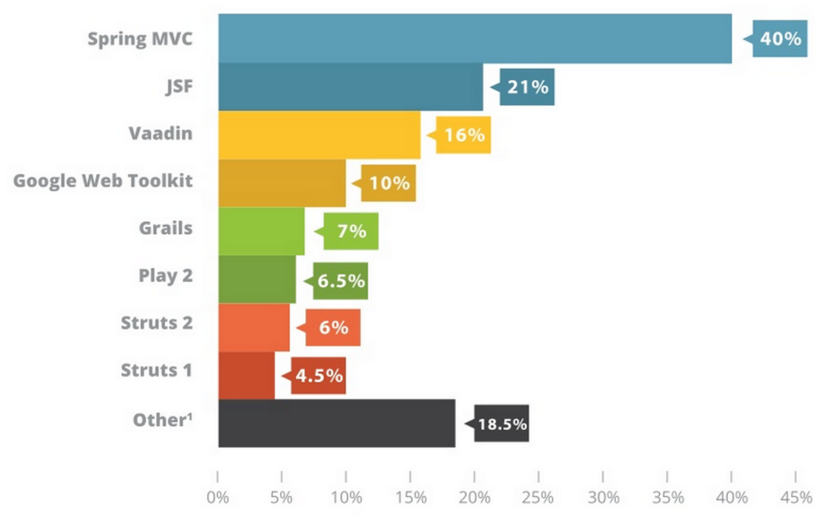

fig 3.1

In November 2014 software developer blog spot [www.vitalflux.com](http://www.vitalflux.com) conducted research regarding the most sought after professional positions in JEE framework development. The results are shown in figure 3.2.

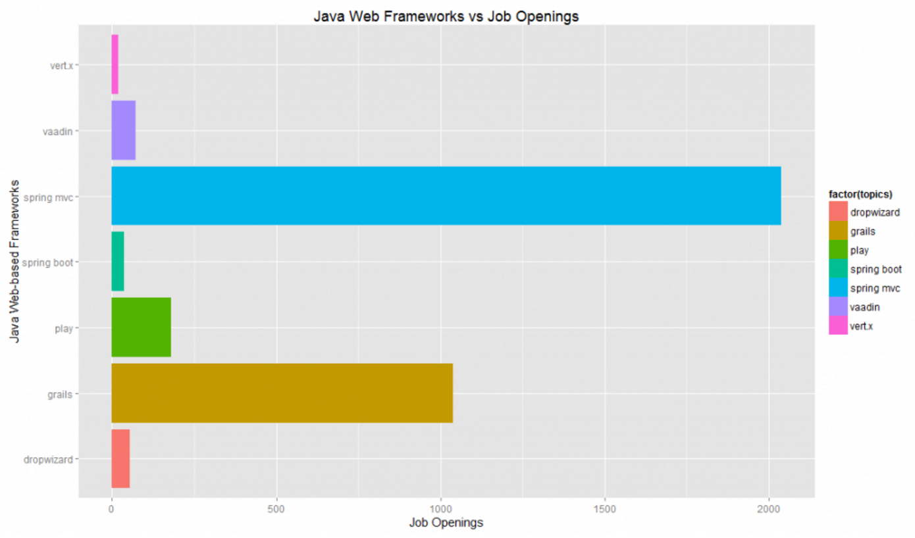

fig 3.2

**4.0 Main Research Questions**

**4.1 Is there a potential gap in the social media market for a fantasy hurling game?**

With many different standardized frameworks available to incorporate into a JEE project, can the choice of framework impact the performance of the final application?

**4.2 Could a fantasy hurling game create revenue for the GAA?**

Mastering a framework comes with a cost, is it worth learning an entire framework for a single project?

**4.3 Could a fantasy hurling game create social media interest for the GAA?**

From the four frameworks researched what area of application development to they best suit?

What are there commonalities between frameworks that allow them to be compared?

**5.0 Benefits**

**5.1 User Benefits:**

\subsection{User Benefits}

Understanding of exisiting frameworks

Knowledge of existing frameworks allow a developer to plan a project while incorporating a framework that can manage a component of the application. Understanding what frameworks do and how they can be utilized increases a developers’ ability to create applications. Researching four frameworks will give a strong foundation on what frameworks are, what they do, how they can be incorporated and when.

Critical ability to compare features of frameworks

Critical analysis of frameworks and their features will be a benefit. Becoming familiar with frameworks and how they are comprised and implemented can further the ability of a developer to build an application employing the correct framework with maximum impact with the smallest overhead. It is not necessary to have large amounts of classes that are unimplemented if only few classes are needed

Learning how to develop with chosen framework while building prototype

After choosing the framework to develop the JEE prototype, the developer will learn valuable skills regarding the implementation of the framework. Using and IDE and downloading the plugin and classes needed then learning about the modules available to create a complete JEE application.

**5.2 GAA Benefits:**

\subsection{Project Benefits}

Ability to develop application faster

Correctly implementing the framework in to the prototype project should accelerate application development while increasing the functionality of the final application.

Example of chosen framework in prototype application

Upon completion of this project an example application created with a chosen framework should show the capabilities and improvements possible when incorporating the correct framework in to the JEE application

Knowledge of other frameworks that have potential use

While this project intends to use one of the researched frameworks to create a prototype application, It is possible to incorporate multiple frameworks in to a single project. Knowing what frameworks can do will benefit the projects ability to incorporate more than one if extended or upon removal and replacement of existing framework.

\subsection{Future Benefits}

Creating a prototype application will show the capabilities of the framework. Further mastering of the chosen framework can be used on larger projects in future. After the initial cost of the learning curve for the first project, future project development will be quicker and can use other frameworks touched upon in research project.

**6.0 Feasibility**

When under taking a project of this scale questions must be asked in order to understand if this project is feasible.

* Does the team have an understanding of the technical requirements necessary?
* Can the team create this project in the time allocated?
* Can measures be taken to aid the progress of this project?
* Will the project fit within the allocated budget?

**6.1 Does the team have an understanding of the technical requirements necessary?**

The team came across many technologies that can be used to successfully create this project. The team of three have the required technical skills to design and build a website backed with a java server using technologies such as.

|  |  |
| --- | --- |
| * HTML * CSS * XML * JSON * AJAX | * JQuery * PHP * JavaScript * JAVA |

**6.2 Can the team create this project in the allocated time?**

|  |  |  |
| --- | --- | --- |
| TASK | DATE | CHK |
| **Phase 1** | **2014** |  |
| Market research | 22/9 - 26/9 |  |
| Evaluate Existing games | 22/9 - 26/9 |  |
| Research copyrights | 22/9 - 26/9 |  |
| Research suitable software | 29/9 - 03/10 |  |
| Asses project feasibility | 29/9 - 03/10 |  |
| Select SDLC | 06/10 - 10/10 |  |
| Create specifications | 06/10 - 10/10 |  |
| Select software | 06/10 - 17/10 |  |
| Propose staff tasks | 13/10 - 17/10 |  |
| Evaluate task timescales | 13/10 - 17/10 |  |
| Design website and logo | 20/10 - 31/10 |  |
| Create UML | 27/10 - 14/11 |  |
| Design database | 17/11 - 28/11 |  |
| Assign staff tasks | 1/12 - 5/12 |  |
| Create website | 8/12 - 21/12 |  |
| **Phase 2** | **2015** |  |
| Implement JSON & AJAX | 26/1 - 27/2 |  |
| Create database | 26/1 - 27/2 |  |
| Link database to website | 02/3 - 13/3 |  |
| Document task completion | 8/12/14 - 13/3 |  |
| Select testing model | 16/3 - 20/3 |  |
| Test system iterations | 23/3 - 17/4 |  |
| Select final iteration | 20/4 - 24/4 |  |
| Deploy system | 27/4 - 01/5 |  |

The team has created a task timeline to keep a record of all the tasks and the time each task is allocated. Breakdown of tasks and giving each task a completion date accommodates workloads and proves the feasibility of this project.

**6.3 Can measures be taken to aid the progress of this project?**

Incorporating a systems development life cycle (SDLC) in to our project can help designate work. Allocating tasks to certain aspects of the project process can help the team distinguish tasks. Tasks can then be delegated to team members depending on their ability to in specific areas of the project. Our team has chosen to use the Waterfall model.

The waterfall model separates the project in to five stages. Each phase of the model must be completed before progressing on to the next phase.

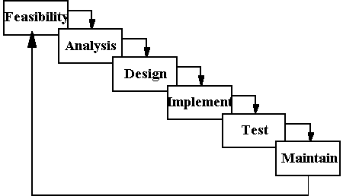

**Advantages**

* Simple and easy to understand and use.
* Easy to manage due to the rigidity of the model – each phase has specific deliverables and a review process.
* Phases are processed and completed one at a time.
* Works well for smaller projects where requirements are very well understood.

**Disadvantages**

* Difficult to move back stages
* No working software is produced until late during the life cycle.
* Not a good model for complex and object-oriented projects.
* Poor model for long and ongoing projects.

**6.4 Will the project fit within the allocated budget?**

Currently there is no budget for the project. This project is merely a demonstration of how a social media game system can be created and implemented. Currently with no competition for a fantasy hurling game on the market, a stylish, user friendly game that can be implemented easily could be sold to a potential client like the GAA.

**7.0 Proposed Methodologies**

**User**

The users experience will begin with creating an account and logging in to their profile. Once the user is within their profile they will be given the option to create a fantasy team. Each user will get a starting budget of €100m and must select a team of 20 players (1 goalkeeper / 14 outfield starters / 5 substitutes). Each player will have a valuation relative to his real life ability. Users will only be able to create a team within their allocated budget of €100m.

The user will have the option of allowing the use of their GPS coordinates to find fellow fantasy hurling users in their area. Users can then message with each other, invite users in to a league or challenge each other to head-to-head matches.

* Creating an account
* Logging in
* Customizing a profile
* Creating a team
* Creating a league
* Inviting users
* Challenging users
* Messaging services

**Administrators**

The administrators will maintain the functionality of the system, from the website interface on the client side to the up to data on players after each game week. The valuation of a player in the fantasy market shadows his performances of the real life. After every game week the administrator will update the data on players. Using this data the system will automatically adjust the users fantasy team in their respective leagues and their head-to-head matches.

* Website maintenance
* Updating player price
* Updating player score
* Updating available players

**8.0 Expected Results**

With no current social gaming outlet for hurling fans this project could prove fruitful. The potential gap in the market could exist for a game like this to succeed. A successful game could function by itself but could also be sold to the GAA and implemented on their website in a similar fashion to the premier league fantasy football.

The GAA could be interested in integrating a social media game on their website to attract the number of followers they have on social media. A fantasy hurling game could increase traffic on the GAA website and generate user interaction, leading to increased advertising revenue.

With social media friends challenging, debating and boasting about their fantasy team though various social media outlets, the GAA can reap some free publicity and advertising for upcoming games.

**8.1 Successful Project**

A successful implementation of this project would create an exciting social environment for hurling fans. The fantasy hurling game would allow users to post their results and scores on social media sites. To be successful users should find the website interface easy to navigate. Playing the game should be intuitive and simple. Selecting to use your GPS coordinates to find other users in your area should be fast. Users should be able to retrieve their fantasy teams results on the final day of a game week. The server should be responsive and load player information quickly. The user-to-user messaging service should be used frequently, for both challenging and talking about hurling. The system should be modular and deployable for a number of different sports.

The game should be complete and function well enough to potentially be sold to a third party, namely the GAA. With out deconstructing the system the game could be implemented on to a new website with little disruption. This would make the game profitable and marketable. This would be the ultimate goal and a truly successful project.

**8.2 Successful System**

A successful system would implement all the functionalities outlined in the methodology. Users could create and account, login, customize a profile, create a team, create a league, invite users, challenge users and use the messaging features within the system. The client side of the system would interact with the database. Data related to players scores and results would dynamically update on the client side after being updated by the administrator on the server. However if the game failed to attract interest from gamers and investors, the project may prove to have been created in vain. A successful system could be modified to adapt to different sports but without users playing the game the project would be considered incomplete.

**8.3 Failed Project**

A failure to create a functioning system that allows users to play the game would be considered a failed project. The project aims are to create fantasy hurling gaming system with social media capabilities that can operate as a standalone website. Potentially if the system created was successful and the market was there for hurling fans, users of social media and an investor to interact and back the game, the project would be considered successful. Failure to create a functioning system however has a knock on affect to potential investors. How can an investor buy a system that does not exist? A failed project can only occur if the team fails to build the system.

**8.4 Incomplete Project**

Failure to complete the system before the deadline could be considered a failed project. The difference between incomplete and failed is that the team mismanaged the time allocated to create the project. The system could still be completed in future iterations. If the system is completed outside of the allocated time and the market still exists for a fantasy hurling game with social media capabilities, the project may not be considered failed and could still potentially be distributed at a later date.

**9.0 Conclusion**

In order to begin the analysis phase of the project the team must research all the data relevant to the proposed fantasy hurling game with social media capabilities, Information about social media interaction between the GAA and hurling fans. With no current game similar to the proposed project available, there appears to be room in the social media gaming market for a fantasy hurling game to exist and benefit fans of the sport and the organizers.

Fans can use the game as an outlet to interact with fellow hurling fans and feel involved in their sport. The GAA can use the game to attract visitors to their website. The project would need to consult the GAA over licensing laws and complying within the existing copyright laws.

The team involved has all the necessary skills to implement this project. Referencing the task time line in 6.2, the project is feasible within the allocated time. The most difficult parts of the project will be creating the website and updating the real life player ratings on the database.

**10.0 References**

1. 2014. . [ONLINE] Available at: <https://www.facebook.com/officialgaa>. [Accessed 19 October 2014].

2. 2014. . [ONLINE] Available at: <https://www.facebook.com/Hill16Dubs>. [Accessed 19 October 2014].

3. 2014. . [ONLINE] Available at: <https://www.facebook.com/officialdonegalgaa>. [Accessed 19 October 2014].

4. 2014. . [ONLINE] Available at: <https://www.facebook.com/OfficialKerryGAA>. [Accessed 19 October 2014].

5. GAA: 20 games live on Sky Sports | Watch Sky Sports | News, Live Sports, TV Shows. 2014. *GAA: 20 games live on Sky Sports | Watch Sky Sports | News, Live Sports, TV Shows*. [ONLINE] Available at:<http://www1.skysports.com/watch/news/9338681/gaa-20-games-live-on-sky-sports>. [Accessed 19 October 2014].

6. Fantasy Gaelic - Play it your way. 2014. *Fantasy Gaelic - Play it your way*. [ONLINE] Available at: <https://www.fantasygaelic.ie/>. [Accessed 19 October 2014].

7. Fantasy Premier League - The official fantasy football game of the Barclays Premier League. 2014. *Fantasy Premier League - The official fantasy football game of the Barclays Premier League*. [ONLINE] Available at: <http://fantasy.premierleague.com/>. [Accessed 19 October 2014].

8. premierleague.com Site Overview. 2014. *premierleague.com Site Overview*. [ONLINE] Available at: <http://www.alexa.com/siteinfo/premierleague.com>. [Accessed 19 October 2014].

9. gaa.ie Site Overview. 2014. *gaa.ie Site Overview*. [ONLINE] Available at: <http://www.alexa.com/siteinfo/gaa.ie>. [Accessed 19 October 2014].